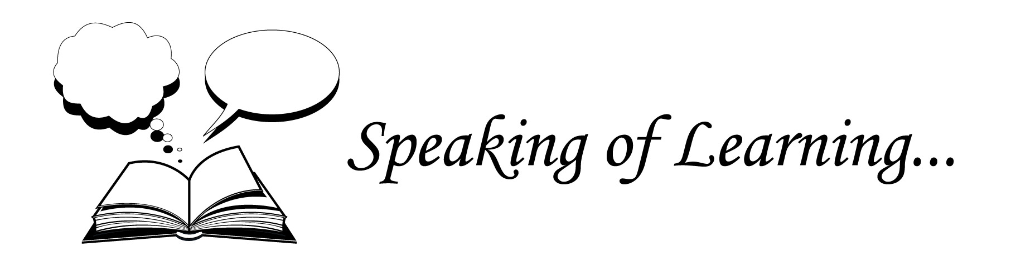

Exploring Autism Spectrum Disorder
A facilitated workshop for parents and carers

Louise Rowland – our Senior Speech Pathologist at Speaking of Learning… – has 28 years’ experience as a practising Speech Pathologist. At Speaking of Learning…, she has had the opportunity to provide intervention to children and adults on the autism spectrum and their families. In addition, Louise has first-hand experience of living with those on the Spectrum.

Over the course of two hours, Louise will offer her perspective on interpreting a range of behaviours seen by children on the spectrum. Participants will be invited to share specific anecdotes.

Date: Wednesday, 14th October.
Time: 7-9 pm
Location: Suite 3, First Floor, 1 Rooks Rd, Mitcham (behind Early Settler Furniture)

Cost: Earlybird rate - $79 per person or $120 per couple
Standard rate - $99 per person or $150 per couple

Registration: Earlybird rate available before Friday October 2nd.
Payment required by Friday, 9th October, by calling the number below.

For further information, please contact us on 9873 7043, or via email at
info@speakingoflearning.com.au

